Importance of Polymathic Thinking and Its Role in Music Teaching and Learning

RIME 2015
Ninth International Research in Music Education Conference

Peter Webster
University of Southern California

This is a presentation about the importance of deep and sustained multidisciplinary thinking—thinking that is born out of a commitment to understand the important conceptual issues of multiple disciplines in service to solving problems or advancing a mission.

This is a presentation about how vital it is to craft undergraduate and graduate programs in music teaching and learning that welcome and celebrate this kind of thinking.

It is a presentation that is based on a belief that nothing of lasting value is ever understood in isolation but in tandem with other intersecting knowledge, skills, attitudes, and values that help explain what is complex and profound.

It is not a presentation about expecting our standards in teaching about music to be lowered because of time dealing with our subject. But rather it is above strengthening our resolve to teach music better and more comprehensively.

Not about interdisciplinary teaching that abdicates our engagement to another team member, although that model has its merits.

This is a personal topic for me. From my earliest days in graduate school, I became aware of the work by psychologist and educators on creativeness and it has fueled many fires in my career in considering implications for music teaching and learning. I believe that I became deeply interested in cross disciplinary work without really knowing much about what I was doing. I believe that this story is not unusual and many of us have taken similar paths. Perhaps we should recognize this more completely in our teaching.

Upon arrival at USC, I encountered a program centered in the library based on a active exploration of something called “polymathic” thinking. This program inspired the beginnings of this paper.

The USC Sidney Harman Academy for Polymathic Study offers a series of conversational encounters intended to intensify polymathic (integrated interdisciplinary) awareness. Conversations and other forms of presentation include faculty, junior faculty, postdoctoral scholars, graduate students, and undergraduates. These discussions are anchored in and structured by the Four Quadrants of Polymathic Inquiry: critical and integrative thinking, study of the great polymaths, tapestry, and communication. (http://polymathic.usc.edu/)

2. What does “polymath” mean and why is it important in general?

Term comes from the greek, polymaths, a person whose expertise spans a significant number of different subject areas.

A polymath draws on complex bodies of knowledge to solve specific problems.

The term was used in the Renaissance in light of the humanistic movement—the idea that humans are limitless in their capacity for development

In Britain, term used to refer to sports figures who excel at more that one sport.
Example: Benjamin Howard Baker who was a famous footballer and high jumper

British poet Robert Twigger has written on the importance of the polymath as opposed to the “monopath” a person with a narrow mind, one-track brain, a bore, a super-specialist, an expert with few other interests. He argues that this kind of professional is often sought after and revered in our Western culture. He writes that our world would be a better place with just the opposite.

Many points from his essay, “Masters of Many Trades” from the Aeon Magazine webpages (http://aeon.co/magazine/culture/anyone-can-learn-to-be-a-polymath/)

For Twigger, from his study of creative achievement comes clear evidence that polymathic thinking is in fact at the core of most major achievements:

“Science, for example, likes to project itself as clean, logical, rational and unemotional. In fact, it’s pretty haphazard, driven by funding and ego, reliant on inspired intuition by its top-flight practitioners. Above all it is polymathic. New ideas frequently come from the cross-fertilisation of two separate fields. Francis Crick, who intuited the structure of DNA, was originally a physicist; he claimed this background gave him the confidence to solve problems that biologists thought were insoluble. Richard Feynman came up with his Nobel Prize-winning ideas about quantum electrodynamics by reflecting on a peculiar hobby of his — spinning a plate on his finger (he also played the bongos and was an expert safe-cracker). Percy Spencer, a radar expert, noticed that the radiation produced by microwaves melted a chocolate bar in his pocket and developed microwave ovens. And Hiram Maxim, the inventor of the modern machine gun, was inspired by a self-cocking mousetrap he had made in his teens.”

“One could tell similar stories about breakthroughs in art — cubism crossed the simplicity of African carving with a growing non-representational trend in European painting. Jean-Michel Basquiat and Banksy took street graffiti and made it acceptable to galleries. In business, cross-fertilisation is the source of all kinds of innovations: fibres inspired by spider webs have become a source of bulletproof fabric; practically every mobile phone also seems to be a computer, a camera and a GPS tracker. To come up with such ideas, you need to know things outside your field. What’s more, the further afield your knowledge extends, the greater potential you have for innovation.”

He notes that learning is aided neurologically by the nucleus basalis, createing acetylcholine – a neurotransmitter that stimulates connections. Active in young people and less so as one gets older unless you stimulate it by working and doing a number of things. He argues for older people staying mentally active by considering polymathic behaviors.

New field:

“Call it polymathics. Any such field would have to include physical, artistic and scientific elements to be truly rounded. It isn’t just that mastering physical skills aids general learning. The fact is, if we exclude the physicality of existence and reduce everything worth knowing down to book-learning, we miss out on a huge chunk of what makes us human.”

3. Who are the famous polymaths?

There are a number of lists. Some on many lists include the great geniuses of our civilization that are known for their achievements in multiple disciplines: Aristotle, da Vinci, Michaelangelo, Archimedes, Pythagoras, Copernicus, Newton, Kant,

More recently: Thomas Jefferson, Ben Franklin, Bertrand Russell, Albert Schweitzer, Jacques Cousteau

Today (for me): Douglas Hofstadter, Noam Chomsky, Jean Piaget, Brian May, Jonathan Wolfe Miller, F. Story Musgrave, Howard Gardner

In music, recent people come to mind for me, others for you I am sure:

Billy Taylor
Yo Yo Ma
Brian Eno
David Byrne
Todd Machover
Jeanne Bamberger

4. Field of music teaching and learning as inherently polymathic

Why is this so important for our field of music teaching and learning? Because our field is almost inherently polymathic. Music theory, history, composition and even applied music in the form of performers and conductors have some history with polymathic work. Kline and Parncutt (2010) have recently reviewed many of these. However it is the music education scholar that is faced with some of the most compelling needs to be polymathic. Such professors and their students are often held accountable for in depth understanding of music theory, history, and performance AND we must certainly understand children’s capacities for learning, specific pedagogies, philosophical positions, technology and related media, allied arts, political implications and realities, interpersonal skills, social context issues, and a host of additional domains outside of music as a whole. This creates a most daunting array that leads to exciting challenge.

Aside: From time to time I feel that we need another label to describe those of us that welcome this challenge and try to rise to the occasion in our personal reading, thinking, speaking and writing: Not “music educators” perhaps since that is too general and loaded with K-12 only biases. How about “Music Teaching and Learning Scientists” or if that is too prickly for you, try “Music Teaching and Learning Scholars.” Helps at cocktail parties perhaps.

How about closer to home: people whose names come to mind that have distinguished themselves in their work as polymathic thinkers. Think of those that have been powerful for us as we imagine the advancement of our field:

John Paynter,John Sloboda, David Hargreaves, Pamela Burnard, Susan O’Niell
Gary McPherson and Graham Walsh, Margaret Barrett

Bennett Reimer , David Elliott , Estelle Jorgenson, Richard Colwell, Janet Barrett, , Robert Duke, Cliff Madsen, Donald Hodges, Andreas Lehmann, Wilfried Gruhn, Jackie Wiggins, Sandra Stauffer, Randall Allsup, Liora Bressler

Others could be listed of course. A number of younger scholars emerging now could easily be added.

These folks perhaps do not rise to the notoriety of the geniuses for the greater society, but each has shown extraordinary insight into our field of music teaching and learning by understanding many many other fields of study including those in education, philosophy, neurology, psychology, and more. Each of these individuals has influenced our field from a polymathic perspective.

5. Question of depth and ownership.

Interestingly, “interdisciplinary collaboration” between experts is not quite what is under consideration here. “Interdisciplinary work” can be confused with individual polymathic thinking. Such work is fine and in some cases represents exemplary teaching practice as perhaps an art teacher and a music teacher work together on an artistic idea such as form or color. What likely occurs in this case is that each teacher explores and “owns” his or her subject with no real intention of delving too deeply into the other.

But what I have in mind here is that an individual feels deeply about understanding another field personally and works hard at achieving a deep and lasting level of understanding about it and actively considers this “other field” in relation to their own.

Specifically from the list above:

Donald Hodges (neuroscience)
Bennett Reimer (arts philosophy)
Jackie Wiggins (epistemology)
Richard Colwell (assessment)

Each of these scholars have contributed greatly to the personal understand of music teaching and learning and another mastered discipline

6. The Emerging Field of Learning Science (LS)

As an example in deep thinking about teaching and learning and other fields, consider the emerging field of Learning Science that as gotten traction in our schools of education. Nathan and Sawyer, 2014 provide these points:

- Learning science draws on a number of theoretical perspectives on learning phenomena as they occur across a broad range of physical, social, and technological spaces.

- Bridging research and practice – working in real-world settings with real-world problems.

- Grows out of an engineering ethos: Highly-responsive/evidence based

- Situated cognition and a phenomenological philosophy base. Social and physical environments are considered along with the individual learner.

- Constructivism as a underlying epistemology. Social constructivism in particular

- Social cultural theory as espoused by Vygotsky and others

- Systemic research (social-based/system based) together with elemental (individual) research.: For example study of creativeness can be approached from a sociocultural perspective vs. and individual perspective

Halverson and Sheridan (2014) have argued that arts learning has important implications for our understanding of learning in general. Arts have three important characteristics that have implications for understanding learning as a whole: (1) they are a representational domain and learning in the arts involves becoming increasingly aware of how representational choices communicate meaning to different audiences, (2) form and meaning are deeply integrated in the arts and subtle changes in how arts materials are organized have important consequences for meaning (3) work in the arts often involve explicitly exploring and examining identity and culture. Their review of the evidence of how people learn in the arts include four broad themes: (1) creation of representation, (2) engagement identity processes, (3) language development (communication), (4) creativity and design thinking.

The Point: The basis for understanding learning science requires a major commitment of time and energy to learn about several other domains.

7. Better ways to engage our students in pathways that lead to this disposition.

Undergraduate Level
- Take seriously the College Music Society’s recently published manifesto, Transforming Music Study from its Foundations: A Manifesto for Progressive Change in the Undergraduate Preparation of Music Majors. Encourage undergraduate curriculum reform that supports creativity (composition and improvisation as well as thinking creatively with listening and performing), diversity of content (many styles of music including popular and world music) and connection between silos of music learning (theory, history, performance). This would begin to create a healthy change to restrictive curricula that do not encourage much beyond interpretive performance.
- Add more opportunities for our undergraduate students to develop double majors and areas of concentration outside of music.
- More chance to do collaborative projects with like-minded arts educators where each student begins to form lasting insights into the others’ discipline
- Create more chances for peer learning in groups – fight against isolation.

Graduate Level
- Encourage and even require cognate areas outside of music education
- Create more independent studies that center on exploring other literature (free up the curriculum for more personal choice.
- Encourage the exploration of polymathic subjects for theses and dissertations.
- Support creative ideas such as joint dissertations across disciplines
- Encourage more team teaching where each professor is deeply engaged in both topics

Others?

8. Implications for established professors?

- Take sabbaticals that focus on learning aspects of a completely different discipline
- Do more polymathic projects
- Talk more deeply with our colleagues from other disciplines about the important questions in their field
- Seek out team teaching experiences where each team member takes ownership of shared intellectual content
- Participate in artistic projects where the team learns deeply from one another
- Think about a difficult music-related problem from directions based outside of music
- Become skilled at something completely different from what you do on a daily basis

9. Institutional Problems with Polymathic Thinking

Pfirman and Martin (2010) document some issues with facilitating interdisciplinary scholars (see table below)

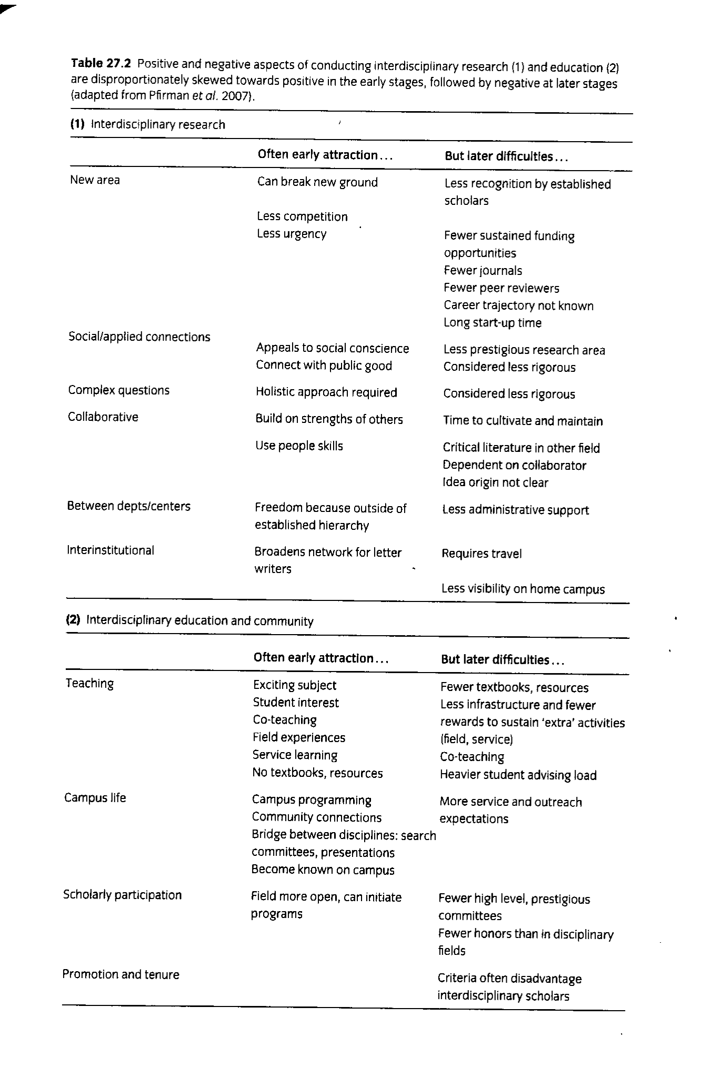

Citations Supporting Presentation

Halverson, E. & Sheridan K. (2014). Arts education and the learning sciences. In R. K. Sawyer (ed.) The Cambridge handbook of learning sciences, 2nd ed. Pp. 627-646. New York, NY: Cambridge University Press.

Klein, J. & Pancutt, R. (2010). Art and music research. In R. Frodeman, J. Klein, & J. Holbrook (eds.) The Oxford handbook of interdisciplinarity, pp. 132-146. New York, NY: Oxford University Press.

Nathan, M. & Sawyer, R. K. (2014). Foundations of the learning sciences. In R. K. Sawyer (ed.) The Cambridge handbook of learning sciences, 2nd ed. Pp. 21-43. New York, NY: Cambridge University Press.

Pfirman, S. & Martin, P. (2010) Facilitating interdisciplinary scholars. In R. Frodeman, J. Klein, & J. Holbrook (eds.) The Oxford handbook of interdisciplinarity, pp. 287-403. New York, NY: Oxford University Press.

Twigger, R. Master of Many Trades, Aeon Magazine online (http://aeon.co/magazine/culture/anyone-can-learn-to-be-a-polymath/) (retrieved April 2, 2015)

Other Useful Resources

Barrett, J.R. (2001). Interdisciplinary work and musical integrity: interdisciplinary connections can open up possibilities for comprehensive study while preserving the integrity and validity of musical experience. Music Educators Journal, 87(5), 27-31

Barrett, J. R., McCoy, C.W., & Veblen, K.K. (1997). Sound ways of knowing: Music in the interdisciplinary curriculum. Belmont, CA: Wadsworth.

Barry, N.H. (2008). The role of integrated curriculum in music teacher education. Journal of Music Teacher Education, 18(1), 28-38.

Burton, L.H. (2001). Interdisciplinary curriculum: retrospect and prospect: new research in interdisciplinary studies provides fresh insights into ways of fostering constructive communication and fruitful exchange among the disciplines. Music Educators Journal, 87(5), 17-66.

Curtis, L. & Fallin, J. (2014). Neuroeducation and music: collaboration for student success. Music Educators Journal, 101(2), 52-56.

